SAVEETHA SCHOOL OF ENGINEERING
SAVEETHA INSTITUTE OF MEDICAL AND TECHNICAL SCIENCES
INSTITUTE OF CSE
CSA15- CLOUD COMPUTING AND BIG DATA ANALYTICS
LIST OF EXPERIMENTS
9. Create a simple cloud software application for Hospital information system for
SIMATS Hospital using any Cloud Service Provider to demonstrate SaaS with fields of
patient name, age, address, phone, email, Attender name, attender phone, doctor name,
diseases, etc.
INPUT:
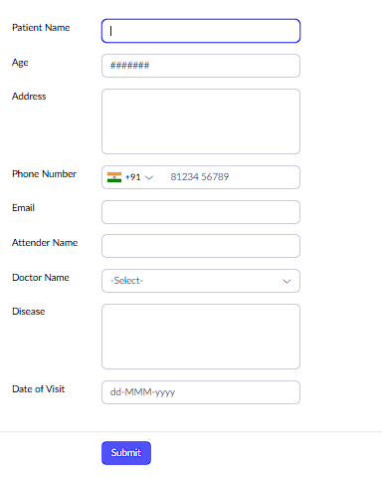

OUTPUT:

